**edcom Ad Venture Student Competition 2015-2016:   
Jury First Round**

Academics

**Dan Petre, SNSPA, Romania**

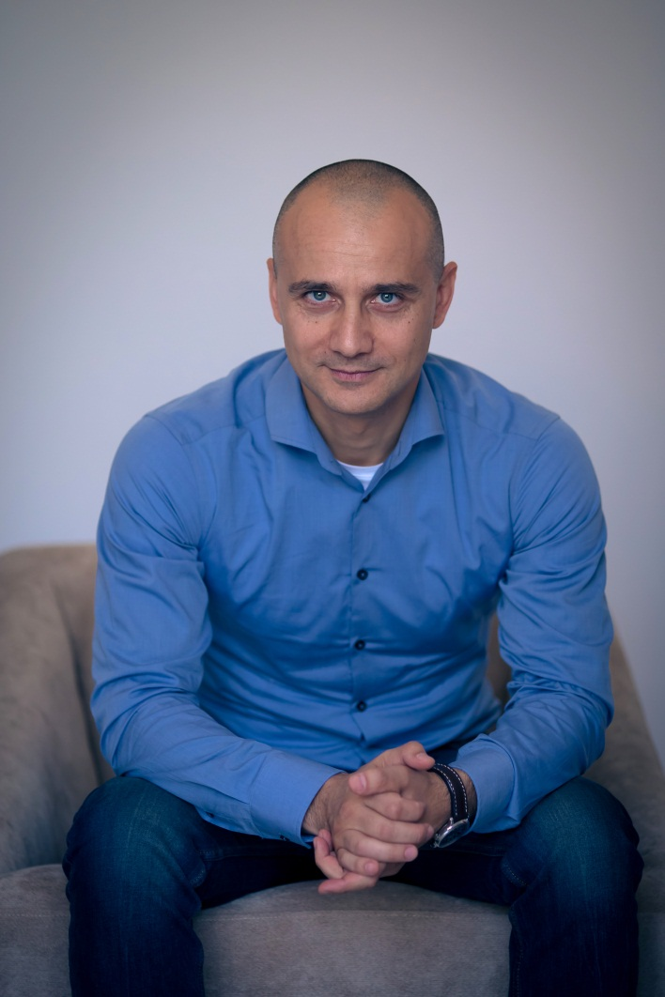Dan Petre has a PhD in Sociology and is a renowned expert in communication sciences. He is active both in the business field, as Partner within D&D Research and also in the academia, as Lecturer within the Communication and Public Relations University in Bucharest (SNSPA). Dan is also one of the board members of IAA Romania (International Advertising Association). After 20 years of activity, he has an extensive knowledge of the Romanian Marcomm industry and is an acknowledged speaker in marketing and research events. He is also the author and co-author of several volumes regarding advertising and consumers psychology.

**Cagri Sumengen, NHTV, Netherlands**

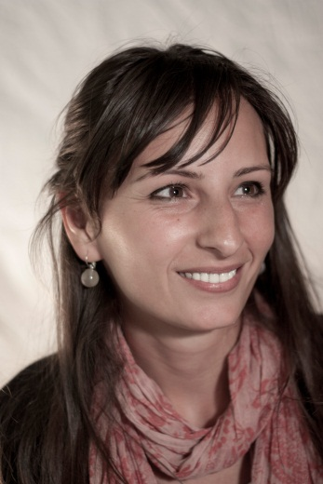Cagri studied Political Science and Public Administration in Middle East Technical University (Turkey) and at the same time she had her Double Major in Philosophy. Later on she gained experience in finance sector and worked as commercial banking product developer in Turkey Isbank (2008) where she was involved in product development and price management projects. She also contributed developing and improving legal regulations concerning banking sector in Turkey. She worked in coordination with marketing departments and continued this coordination in Mindshare Media Planning Agency (2010) where she worked as a consumer insights and research specialist for various global companies such as Nestlé, Diageo, Dyson, IBM and Roche. Before joining NHTV in 2012, Cagri obtained her Master’s degree in Communication and Information Sciences in Tilburg University (the Netherlands). Currently at NHTV she teaches various subjects such as Online Marketing, Media Planning and Advanced Research Methodology where she is also supervising graduation projects and coaching internship students.

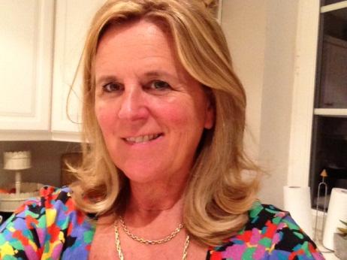**Monique Gerritsen, EPHEC, Belgium**

Monique Gerritsen holds a Masters in Economic Sciences from the Catholic University of Louvain (KUL). She started her career in 1981 at the J. Walter Thompson communications agency. For 20 years she worked as Client Services Director and as a member of the Management team in several international communications agencies (JWT, Grey Worldwide, McCann Erickson and Young & Rubicam) and managed clients in different sectors on a national and an international level. Guest lecturer at the EPHEC since 1999, she started to teach in 2002 and helped to found the communication option in the Haute Ecole EPHEC’s Marketing section. Representing Ephec she is an edcom Research Committee and Board member. Mrs. Gerritsen has also a 8 years’ experience in direct search & recruitment and is since 2011 Co-President and Coordinator of the Belgian Commercial Film Producers Association and she also works as an HR consultant at HC Consulting (office), is a freelance communication consultant and has been a member of the EFFIE Awards’ Organisation Committee for 17 years.

**Kristian Postagian, New Bulgarian University, Bulgaria**

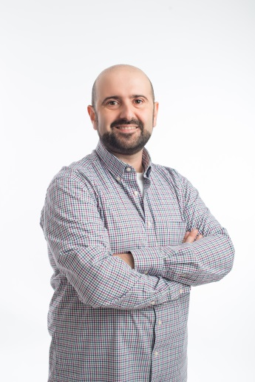Kristian Postagian is a lecturer of advertising at New Bulgarian University since 2003 and co-author and director of the Master Programme "Advertising Management and Visual Branding" since 2010. He teaches the courses "Media Planning", "Principles of marketing communications", "International Advertising", "Visual Merchandising", "Advertising and Media" and others. He has graduated marketing in the University for National and World Economy. He is a PhD, the topic of his work is “Negative impacts of the media environment on the effectiveness of the television and print advertising (development and testing of a system for monitoring)”.

**Sandra Femenia Almerich, Universidad Cardenal Herrera CEU, Spain**

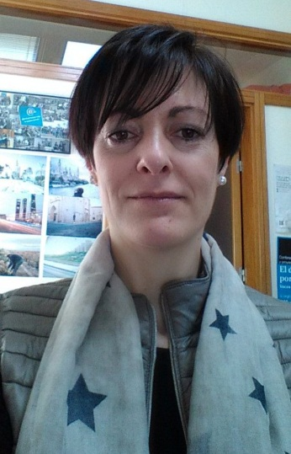Sandra Femenía has a degree in Adventising and Public Relations and has a PhD in Communication through the Thesis: management of Sport Sponsorship focusing on net theory. As a professor, her professional life has been linked to CEU Cardenal Herrera University since 2001. She is the person in charge of subjects such as: Creative Thinking, Corporate Communication, Public Relations Theory, Internal Communication, Advertising and Public Relations Technics, Communication in International Environments, etc. She takes part in 3 groups of research: Drugs Consumption and traffic accidents, Rock and love: interactive communication, Olympic Games, disability and communication. She took part in National and International Congress and Seminars as a speaker, as an organising and scientific committee. She has much experience in organising and managing activities and events, in and for CEU Cardenal Herrera University.

**Catherine LeJealle, ISC Paris Business School, France**

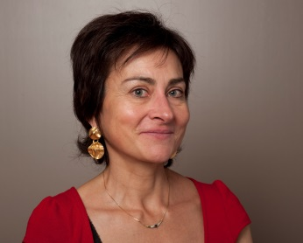Catherine Lejealle is a Telecom engineer who works for IBM, SFR (mobile company) and Arthur Andersen in sales, marketing and management. She has graduted from Université Paris 5 Sorbonne and has a Ph D in sociology. She's a permanent lecturer researcher in ISC Paris Business School and head of a Digital Marketing and web management MBA.  She writes academic research article, teaches and advices companies as a consultant. Her research field is digital usages.

**Didier Van Ghyseghem, Erasmus Hogeschool Brussels, Belgium**

Didier has a masters degree in Germanic philology and an MBA in marketing, both from Ghent University. In his professional career, he has worked as an account executive, account manager, account director and client services director for various advertising agencies (amongst others OgilvyOne and LG&F) from 1993 until 2008, working on clients such as Proximus, Philips, Mercedes-Benz, Ford. Since 2008, Didier has been a full-time lecturer in marketing communications at the Erasmus University College Brussels.  
  
 **Inge Barkmeijer, The Hague University, The Netherlands**

After ten years of work experience in the field of Marketing and MarCom, Inge Barkmeijer has been lecturing at The Hague University. Inge is dedicated to help students grow into young marketing professionals. Gaining further knowledge and sharing that knowledge in the field of branding, marketing communications and the use of social media in a business context is where her professional interest lies. Passionate about consumer behaviour and international differences, she started studying again and obtained her Master title in International Communication Management in 2010. As a juror in the Ad Venture Student Competition Inge will keep an eye open for the teams that are able to crawl in the footsteps of their persona(s), choose the right tone-of-voice and the most effective channels to make a difference for the client.  
  
**Nele Bylois, PXL, Belgium**

 Motivated communication management teacher/ researcher @PXL, chief geek of Moonfish.eu, specialized in marcom for start-ups, former marketing coordinator in international oriented  BTB & BTC co.’s, >10 years’ experience, inbound-marketing fan, digital media addict, passionate winelover, 30 something year old, personal motto: do it with passion or leave it.

**Tim Hoppen, The Hague University, The Netherlands**

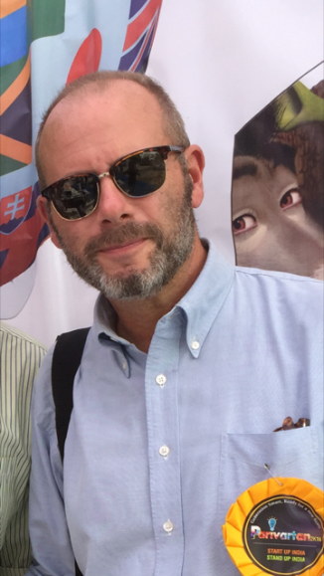 Motivated communication management teacher/ researcher @PXL, chief geek of Moonfish.eu, specialized in marcom for start-ups, former marketing coordinator in international oriented  BTB & BTC co.’s, >10 years’ experience, inbound-marketing fan, digital media addict, passionate winelover, 30 something year old, personal motto: do it with passion or leave it.

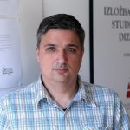  
**Nenad Bogdanovic**

Nenad was a Doctoral candidate of the University of economics Rijeka Croatia, and a M.Sc. of economics at University of economics Zagreb. He is currently Vice dean and Senior Lecturer at the University college of Agora Zagreb, specialised in market communications. Furthemore, Nenad is a consultant for companies,  specialised in tailored inhouse education, organisational issues, quality management, and human resources. Nenad is also a certified REFA-trainer – REFA Bundesverband Darmstadt – and a Certified consultant for entrepreneurship.

**Arnoud Versluis, NHTV University, The Netherlands**

Master in Marketing Strategy, University of Groningen, Netherlands BT (Tourism), NHTV University of Breda, Netherlands Arnoud’s career has covered more than 15 years in several marketing areas. He started out as Marketing manager at De Jong Intra Vakanties (DJIV), a big tour operator in the Netherlands, where he gained experience in all facets of marketing, including sponsorships and advertising campaigns. After leaving DJIV, Arnoud went into the world of advertising and became account manager at Pluspoint & Partners. He was responsible for clients such as Intratuin, Intertoys and Bruna (big retail brands). From the advertising industry, Arnoud jumped into the world of finance. He worked as Brand & PR manager for Unirobe Meeùs Group, one of the biggest Dutch financial intermediaries (insurance, pensions, mortgages) with a brand portfolio of 12 brands. During this time, he was responsible as management team member for all strategic marketing & communicative issues, all internal/external media (including spokesman), several integration programs and he was the initiator of the partnership with Guus Meeuwis, a famous Dutch singer. Before joining NHTV, Arnoud started to work for his own company Arfacom, advice & consultancy in brand strategies, positioning, change- and reputation management. Besides his work as lecturer Marketing at NHTV, Arnoud is also a jury member of the SAN (Stichting Adverteerder jury Netherlands), member of the Foundation board Omroep Brabant (a regional TV, internet and radio company) and a member of Communicatie Netwerk Baronie (CNB), association of marketing professionals. Arnoud looks forward to sharing real-life industry experience with enthusiastic and motivated students.

**Cliff Van Wyk**  
Cliff Van Wyk is Senior Lecturer in Advertising at Bournemouth University, with special emphasis on Strategic Planning and Applied Creativity. Cliff spent 30 years in advertising and marketing consultancy in various parts of the world, prior to joining Bournemouth University in 2006. He has worked for, and with, some of the world’s leading agencies and marketers, such as Lintas, Lowe Worldwide, Unilever, Nestle, Coca-Cola, Dulux, 3M, Mercedes-Benz, HSBC and IBM. He has delivered papers at major international conferences (Global Diversity, Age Matters, Brand Activation) and is actively involved with several industry bodies. Over the past five years, Cliff has guest lectured (and run bootcamps and practical workshops) in Spain, Argentina, South Africa and the Netherlands. He has also served as a judge in several advertising and creative award programmes.

**Madalina Moraru**

My PhD. focused on the mythical dimension of the advertising. Therefore, I authorized 2 books in Romanian and over 20 articles in English, few chapters, I took part in many international conferences (around 25 in the last 7 years). I’m active by getting involved in the industry’s projects, and being invited to the most important events: Advertising Day, Fibra award,member in Romanian Effie Juries. I’m mostly in charge to work with students for AdVenture and Thesis competition.  
  
  
  
  
**Tim Hoppen**

 After graduating in communication and linguistics. I decided to become a travel agent, because I enjoyed traveling so much. Eight years later I switched to Education. I have been working at THUAS for more than 20 years, where I lecture communication and critical thinking. Furthermore I am the chair of the thesis committee and I am part of the curriculum committee and a research group. My fields of expertise are: Lecturing, Connecting people, Study career guidance, Study tracking systems, Curriculum development, Management of courses, Communication and marketing communication, Business Communication, Critical thinking, Creating links between education and business, Internationalisation and interculturalisation, International collaboration in education, Supervising (international) projects and (international) internships, Incorporation of intercultural dimensions in education, Thesis tutoring, Assessment of theses.

**Brandi Morris**  
Brandi Morris has spent the lion’s share of her career overseeing the development and execution of cause-marketing campaigns. She recently left the private sector to become a researcher at Aarhus University where she is using behavioral- and neuroeconomic tools to better understand the astonishing power of stories.

**Barbara von Rechbach**

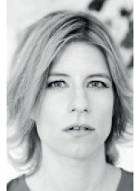

Barbara has 15 years of experience as creative director and consultant for exhibition design and interface design in Berlin, London and Vienna. She is also the director of a design studio and an art consultancy with a focus on narrative design. STUDIO VRD uses a design driven approach for narratives in media exhibitions and digital media experiences.   
  
Since 2002 Barbara has been a lecturer and consultant for media design and visual communication for a range of universities including the University of Applied Arts Vienna and The Berlin University of Arts.

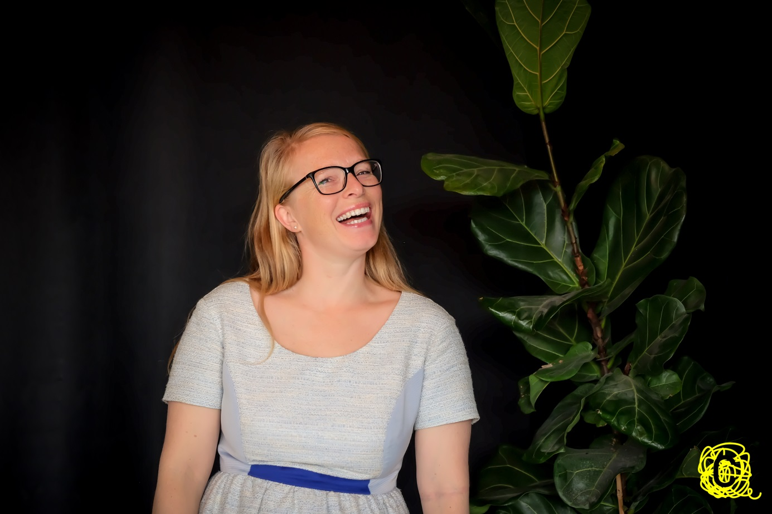**Joanna Desmet**  
After finishing higher education studies in Communications and in History of Art, Joanna Desmet started her career as a market researcher, which she combined with teaching at Howest University College. She coaches students in the fields of Advertising, Internal Communications and Media. She is especially interested in target group definition, strategy and creative thinking because she believes those are the three main ingredients for good communication campaigns. She has been head of the Communications department of Howest but returned after three years to the daily school life of teaching and coaching. Together with her students she works in projects for clients who need help in their corporate or marketing communications strategies but do not have the needed budget to work with professional agencies. She strongly believes in learning by doing and hopes to inspire her students this way.

Client representatives

Industry professionals

**Katerina Houpi, Magnet Advertising, Greece**

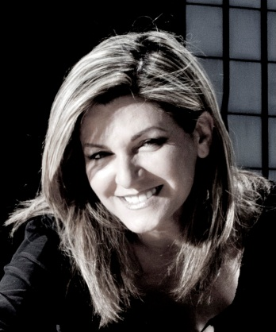Katerina Houpi holds a BSc with Honours in Graphic Design & Advertising from London College of Communication. Katerina has years of experience in advertising. She was an Art Director in Ogilvy, an Art Director and Creative Director in DDB and since 1997 Executive Creative Director in Magnet Advertising. Her creative work for local and international clients has won awards in Greek well International Advertising Festivals. She sings, she performs and she is an avid traveler.

**Barry Ferguson, Carat, United Kingdom**

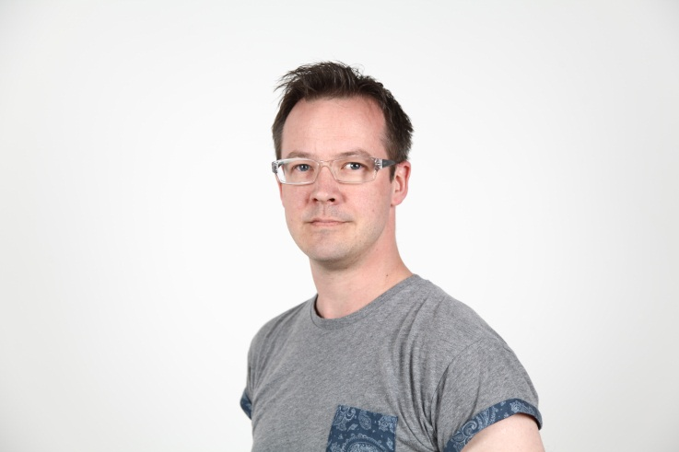Barry has nearly 20 years of communications and advertising experience having worked at New PHD, Capital Radio (Global Radio), OMD, Gamesys, MediaCom and Carat. He is rare in that he has worked on all three sides of the communications industry; he has been a client, a planner and has also worked on the media owner side. As such he has a full perspective of how the industry operates. As you would expect he has worked on hundreds of campaigns for dozens of clients. He has significant experience of both implementation and strategic communications planning but has a specific interest in the psychology of planning, and so any brief with a behaviour change requirement is greeted with a warm smile. He is married with two children and certainly qualifies as a ‘fun’ Dad - “I’m not sure who is more grown up, them or me”. He is a strategy games nut and peers consider him to be an expert at Chess, Backgammon and Poker.

**Serhiy Uryn, THINKMcCANN, Ukraine**

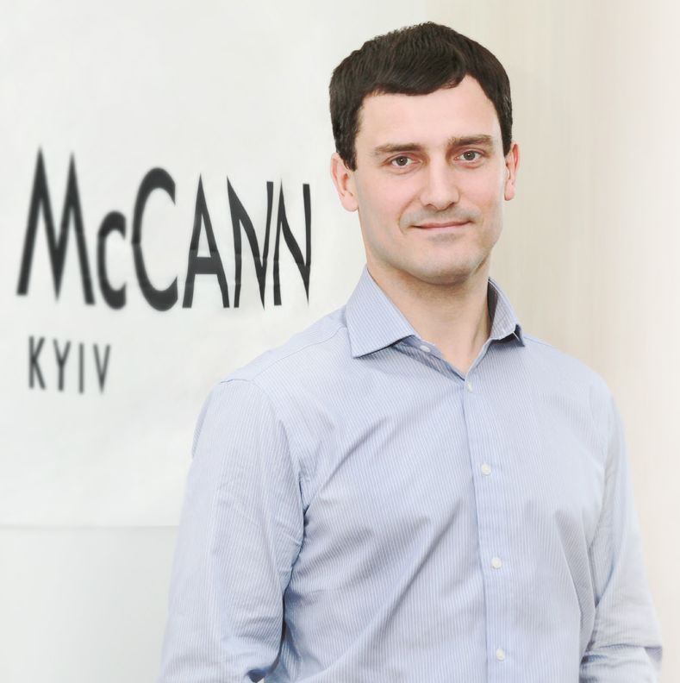Before joining THINKMcCANN, Serhiy worked for InBev in Ukraine and Croatia. He has over 14 years of marketing communication, strategic planning and management experience, the latter includes leading the top agency for the past 7 years. Serhiy has worked with several key categories: beer, non-alcoholic drinks, telecommunication on brands including Stella Artois, Chernigivske, Baltika, Borzhomi, NESCAFE, life:) and many others. Serhiy is a member of EFFIE Awards Ukraine jury for 6 years. Having won over 20 EFFIE awards, THINKMcCANN has been in top creative effectiveness rankings in Ukraine for many consecutive years, including being awarded “The Most Effective Creative Agency of the Year” title twice.

**Steve Colmar, Leo Burnett, Portugal**

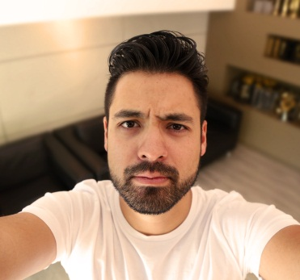Although he’s a Japanese-German descendant, Steve was born in Brazil. He joined Leo Burnett Lisbon in 2009, playing a key role in the team that led the agency to be recognised as the best in the country for 6 consecutive years in El Ojo de Iberoamerica. During these 6 years at Leo Burnett Lisbon, Steve has had the privilege of working with highly talented creative people. Together they managed to win important awards such as Cannes Lions, D&AD, One Show, LIA, Nyf, Eurobest, ADCE, El Ojo, FIAP, Creative Club of Portugal and others. In 2015, Steve was considered the best Creative Director in Portugal’s National Ranking.

**Zelia Moraes, Leo Burnett, Portugal**

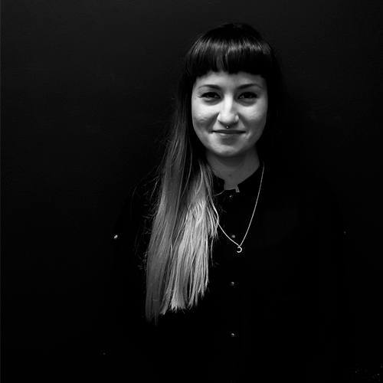Zelia has been working in advertising for the last 13 years and moved from Brazil to Portugal to join Leo Burnett´s creative department in 2008. In seven years at Leo Burnett / Arcww Lisbon she’s created campaigns for clients Samsung, Heineken, Fiat and many others, becoming Digital Creative Director in the LAP Group.

**Heiner Prignitz, BrandGalaxy Group, Germany**

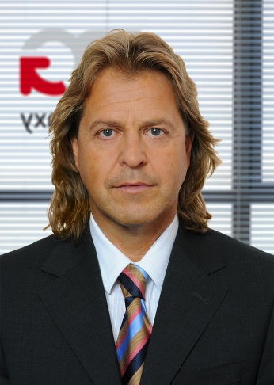Heiner studied economics at the university of Cologne. He has worked for Grey (advertising agency), R.J.Reynolds Tobacco (Camel Cigarettes), pro concept marketing (Field & Sales promotion agency) and since 2015 as a Managing Partner of BrandGalaxy Group (network of different communication agencies with focus on Field & Sales Promotion, PR, Digital, Sponsoring, Events & Fairs, Media) based in Cologne.

**Sorin Psatta, BBDO, Romania**

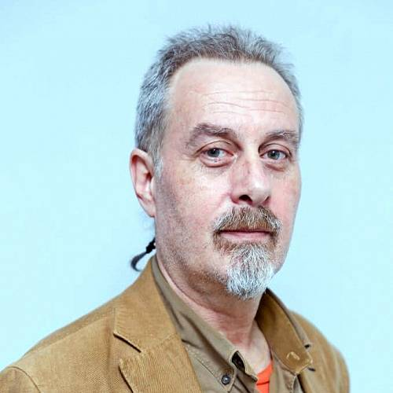Over 20 years in advertising, currently working as Integrated Communication Director at BBDO Romania, contributor of over 30 Effie Awards, elected Personality of the Year in Marketing Communication by IAA Romania and winner of the Excellence in Marketing Education Award (2014). Also lecturer, from 1996, at the Faculty of Journalism and Communication Sciences, University of Bucharest, having as main fields of interests’ consumer behaviour and advertising research.

**Toshka Ivanova, Reforma, Bulgaria**

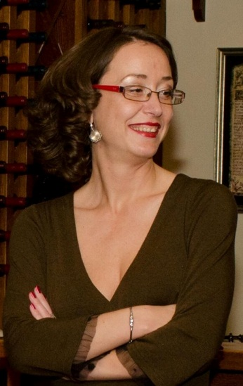Toshka is part of reforma team since 2013. She has 10+ years of experience in Publicis Sofia and Leo Burnett Sofia, being responsible for brands such as P&G, Diageo, Philip Morris, NESTLE, L’Oreal, Unicredit Bulbank. Now she leads a creative team, developing local creative campaigns for MasterCard, Pernod Ricard, Discovery Networks CEEMEA, and more. Toshka is proud and challenged to be part of the only agency in Bulgaria which for the past 4 years creates projects that are awarded both at EFFIE and FARA (the local creative festival). In her work she aims to prove that the right creativity leads to meaningful results.

**Amandine Hähnel, EMMA, Belgium**

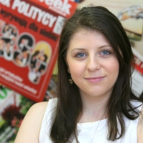Amandine Hähnel has been working at EMMA since April 2010 and is since 2014 its European Affairs Manager. In this position, she deals with EMMA´s advocacy work on VAT, advertising, media pluralism, digital and environmental topics. Amandine holds a French-German double degree in political sciences from the Institut d'Etudes Politiques, Lille (France) and the Westfälische-Wilhelms Universitat, Münster (Germany).

**George Zarogiannis, Soho Square, Athens, Greece**

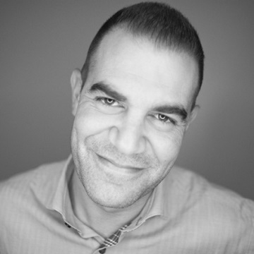George set up the Ogilvy business in Albania in 2013 and ran the new office (as part of Ogilvy Group Greece). In September 2013, George returned in Greece to become the Managing Director of Soho Square Athens (WPP group). Soho Square Athens is considered today as one of the most dynamic agencies in the Greek market. During his career, George has been involved in many different areas in the advertising field for local and international clients such as: Cosmote Greece & Albanian Mobile Communications (part of DT group), Aegean Airlines, Heineken, Japan Tobacco Industry (JTI), The Coca Cola Company, BP - Castrol, Nestle, Carrefour, Piraeus Bank of Greece and Tirana Bank Albania and others.

# John Wright John is currently Director of Strategic Business Development EMEA based out of London, a position he has held since November last 2009. As well as his day to day focus on New Business, John has also been responsible for the global implementation of the proprietary networking platform ‘The NeuralNetwork@McCannWorldgroup’ a revolutionary tool that has transformed the way the business creates, ideates and communicates. He was also part of the global management team that was responsible for the development of ‘McCann 3.0’, the global strategic and creative overhaul of McCann Erickson. Prior to this John spent two years working as a management consultant for his own company Achilles Consulting Ltd. He spent 13 months of that time working for a Global Strategic Planning Consultancy called SCQuARE International Ltd where he held the position of Vice President Sales and Marketing for Europe. Earlier in his career John was Managing Director for Saatchi & Saatchi London and was responsible for the day to day running of the agency and its 500 staff members. He also had profit responsibility for the Agency and was in charge of the Group MD’s. He sat on the UK and European boards. Santiago Gramunt Muñoz Santiago Gramunt Muñoz was vice president of the Association of Spanish Communication and Advertising Agencies between 2013-16. He also acts on the Directors Committee for the Advertising Academy, and is also an adviser to the OJD, the on/off Audit Bureau for Spanish Circulation.

**Jan Binar, McCann-Erickson Prague, Czech Republic**

Jan has been an employee of McCann-Erickson Prague since 1993 – he has worked in several departments: customer services, strategic planning and creative department creating concepts. Over the years he contributed to achieving the title of the most efficient agency of the year twice in last 3 years thanks to efficiency of our campaigns. Jan is also an external lecturer of commercial communication at University of Economics in Prague. He is the president of the Czech Communication Agencies Association, and also a member of the supervisory board of Czech innovation of the year.

# 

Client representatives